Chapter 9: Cellular Respiration: Harvesting Chemical Energy

Overview: Before getting involved with the details of cellular respiration and photosynthesis, take a second to look at the big picture. Photosynthesis and cellular respiration are key ecological concepts involved with energy flow. Study Figure 9.2

Concept 9.1 Catabolic pathways yield energy by oxidizing organic fuels

1. Explain the difference between fermentation and cellular respiration.

2. Give the formula (with names) for the catabolic degradation of glucose by cellular respiration.

3. Both cellular respiration and photosynthesis are redox reactions. In redox, reactions pay attention to the flow of electrons. What is the difference between oxidation and reduction?

4. The following is a generalized formula for a redox reaction:

Xe– + Y → X + Ye–

Draw an arrow showing which component (X or Y) is oxidized and which is reduced. _______ is the reducing agent in this reaction, and _________ is the oxidizing agent.
5. When compounds lose electrons, they _____ energy; when compounds gain electrons, they _____ energy.

6. In cellular respiration, electrons are not transferred directly from glucose to oxygen. Following the movement of hydrogens allows you to follow the flow of electrons. The hydrogens are held in the cell temporarily by what electron carrier? What electron carrier is hydrogen transferred to first?

7. Describe what happens when NAD+ is reduced. What enzyme is involved?

8. It is essential for you to understand the concept of oxidation/reduction and energy transfer. For the following pair, which molecule is the oxidized form, and which is reduced? Which molecule holds higher potential energy? Which is lower in potential energy?

 | Oxidized or Reduced? | Higher Energy/Lower Energy
NAD+
NADH

9. What is the function of the electron transport chain in cellular respiration?

10. Electron transport involves a series of electron carriers.

Where are these found in eukaryotic cells?

Where are these found in prokaryotic cells?

11. What strongly electronegative atom, pulling electrons down the electron transport chain, is the final electron acceptor?

12. Understanding the overall map of how cellular respiration works will make the details easier to learn. Use
Figure 9.6 to label the missing information in the figure that follows.
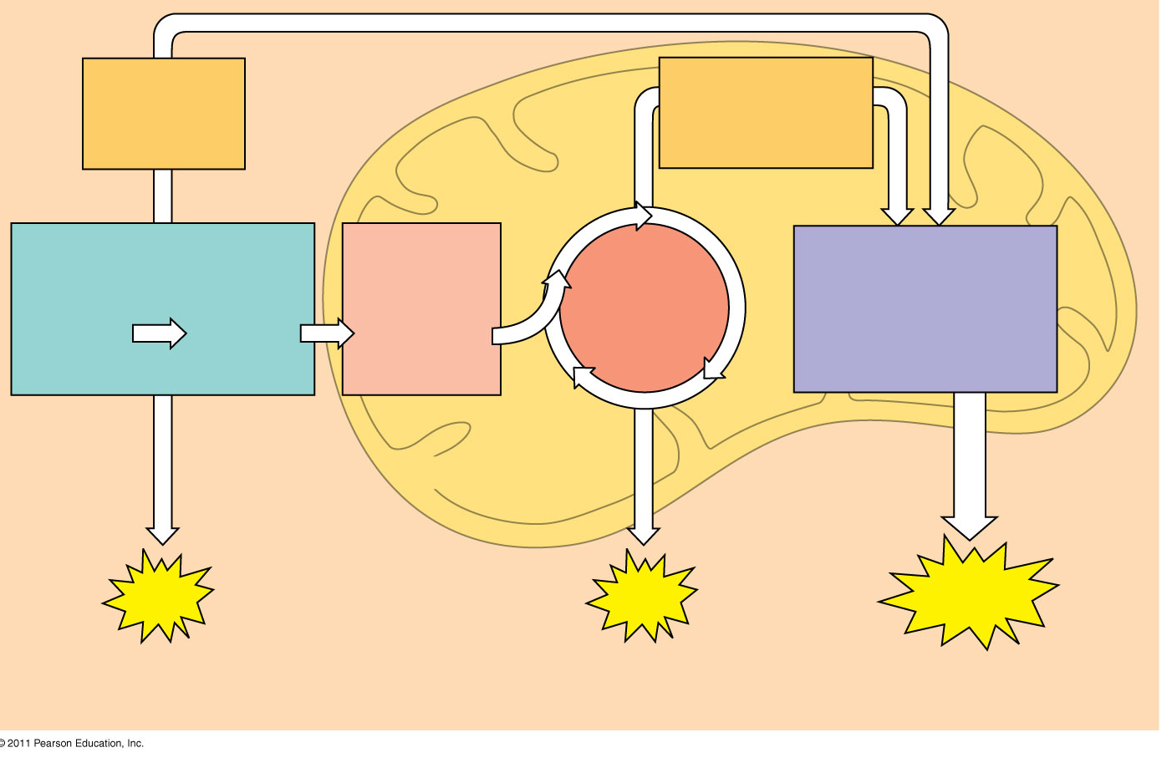
13. Three types of phosphorylation (adding a phosphate) are covered in the text, and two of these occur in cellular respiration. Explain how the electron transport chain is utilized in oxidative phosphorylation.

14. Explain the process of substrate level phosphorylation

Concept 9.2 Glycolysis harvests chemical energy by oxidizing glucose to pyruvate

15. What is the meaning of glycolysis? What occurs in this step of cellular respiration?

16. The starting product of glycolysis is the six-carbon sugar __________, and the ending products are two _____- carbon molecules of ______________________.

The ten individual steps of glycolysis can be divided into two stages: energy investment and energy payoff. These steps are shown in Figure 9.9, which details the enzymes and reactions at each of the ten steps. While you are not expected to memorize these steps and enzymes, you should study the figure carefully. The next few questions will help you focus your study.

17. Notice that glycolysis occurs in the ______________ of the cell. Is oxygen required? ___________

Concept 9.3 After pyruvate is oxidized, the citric acid cycle completes the energy-yielding oxidation of organic molecules

18. To enter the citric acid cycle, pyruvate must enter the mitochondria by active transport. Three things are necessary to convert pyruvate to acetyl CoA. Explain the three steps in the conversion process.

19. Use Figure 9.11 to help you answer the following summary questions about the citric acid cycle:

a. How many NADHs are formed?

b. How many total carbons are lost as pyruvate is oxidized? c. The carbons have been lost in the molecule __________________
. d. How many FADH2 have been formed?
e. How many ATPs are formed?

f. How many times does the citric acid cycle occur for each molecule of glucose?

20. The step that converts pyruvate to acetyl CoA at the top of the diagram occurs twice per glucose. This oxidation of pyruvate accounts for two additional reduced __________ molecules and two molecules of CO2.

21. Explain what has happened to each of the six carbons found in the original glucose molecule.

Concept 9.4 During oxidative phosphorylation, chemiosmosis couples electron transport to ATP synthesis

22. Oxidative phosphorylation involves two components: the electron transport chain and ATP synthesis.
Referring to Figure 9.13, notice that each member of the electron transport chain is lower in free _________ than the preceding member of the chain, but higher in ____________. The molecule at zero free energy,

23. Oxygen is the ultimate electron acceptor. Why is this?

24. Oxygen stabilizes the electrons by combining with two hydrogen ions to form what compound?

25. The two electron carrier molecules that feed electrons into the electron transport system are _______ and______________.

26. Using Figure 9.14, explain the overall concept of how ATP synthase uses the flow of hydrogen ions to produce ATP.

27. What is the role of the electron transport chain in forming the H+ gradient across the inner mitochondrial membrane?

28. Two key terms are chemiosmosis and proton-motive force. Relate both of these terms to the process of oxidative phosphorylation.

Chemiosmosis refers to

Proton-motive force refers to

29. At this point, you should be able to account for the total number of ATPs that could be formed from a glucose molecule. To accomplish this, we have to add the ATPs formed by substrate-level phosphorylation in glycolysis and the citric acid cycle to the ATPs formed by chemiosmosis. Each NADH can form a maximum of ___________ ATP molecules. Each FADH2, which donates electrons that activate only two proton pumps, makes _____________ ATP molecules.

30. Why is the total count about 36 or 38 ATP molecules rather than a specific number?

Concept 9.5 Fermentation enables some cells to produce ATP without the use of oxygen

31. Fermentation allows for the production of ATP without using either __________________ or ______________________________________

32. For aerobic respiration to continue, the cell must be supplied with oxygen—the ultimate electron acceptor.
What is the electron acceptor in fermentation? +
33. Alcohol fermentation starts with glucose and yields ethanol. Explain this process, and be sure to describe how NAD+ is recycled.

34. Lactic acid fermentation starts with glucose and yields lactate. Explain this process, and be sure to describe how NAD+ is recycled.

