VIDEO GUIDE BOZEMAN BIOLOGY – MEIOSIS
- Meiosis is the process by ….

- What is diploid?

- What is haploid?

- What happens in crossing over?

- Describe at least three ways meiosis is different from mitosis.

- How are oogenesis (egg production) and spermatogenesis (sperm production) different?

- According to Mr. Anderson’s video, “you are special” because of what three biological processes?
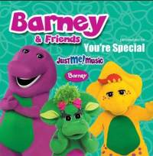

- What are the odds of two people creating to embryos that are genetically exactly the same?

