Created by D. LaFleur Name:

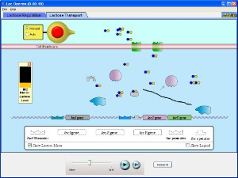 Lac Operon AP Biology PhET Simulation

The goal of this simulation is to help you understand how prokaryotes (note that this is for prokaryotes and NOT eukaryotes) control gene expression. Specifically, this activity will simulate an inducible operon called the lac operon used to control the expression of genes that control lactose levels in bacteria. Again, this is for bacteria only and has nothing to do with lactose catabolism or lactose intolerance in humans.

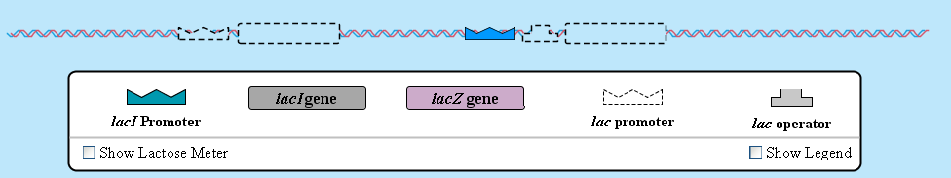

Step 1: Drag the lac promoter to the stretch of DNA. Do NOT drag the lacZ gene to the DNA. What happens? Why is this?

Step 2: Now try dragging the lacZ gene to the DNA and note what happens.

Step 3: Inject some lactose (about 25 molecules should do it) into the simulation. Note what happens. Specifically, what is lactose being converted into?

Step 4: Note that the lac enzyme continues to be produced even in the absence of lactose. Why is this a problem? Try dragging the lac operator gene onto the stretch of DNA. What is the result?

Step 5: Now try adding the lacI promoter and gene to the stretch of DNA. What happens?

Step 6: Again, add some lactose (and again, 25 molecules should work well) into the simulation. What is the INITIAL
result of adding lactose when both genes are activated?

Step 7: Do not add any more lactose and watch what transpires. Note what happens and why this occurs. How could you re-activate the lacZ gene?

Step 8: Now try the lactose transport tab and insert all of the promoters and genes. Add some lactose and watch to see what transpires. What is the role of the lacY gene? How does this help the system?

