S I G N A L S

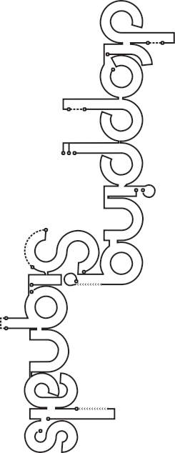
a small protein molecule that travels through the blood stream
Name

Date

Complete the Dropping Signals activity on the Learn.Genetics website. Record the effect of each signal on each cell type in the table below.
Print-and-Go™
http://learn.genetics.utah.edu
genetically
changed skin cell with altered behavior
produce sugar
in plant leaves
responsible for
structural frameworks in body tissues
Skin
Cancer
Leaf
Parenchyma
Fibroblast
S1
© 2008 University of Utah
Permission granted for classroom use.

Hormone
a growth factor in the form of a small protein molecule

Cytokine
a gas produced by cells

Nitric
Oxide
C E L L T Y P E S
contain proteins
that allow them to contract
specialized
cell type in the retina of the eye
Muscle
Photoreceptor
energy that travels freely through space

Light

