Name Period

Chapter 5: The Structure and Function of Large Biological Molecules

Concept 5.1 Macromolecules are polymers, built from monomers

1. The large molecules of all living things fall into just four main classes. Name them.

2. List the three classes that are called macromolecules. Define macromolecule.

3. What is a polymer? What is a monomer?

4. Monomers are connected in what type of reaction? What occurs in this reaction?

5. Large molecules (polymers) are converted to monomers in what type of reaction?

6. The root words of hydrolysis will be used many times to form other words you will learn this year. What does each root word mean?

hydro–

lysis

7. Consider the following reaction:

C6H12O6 + C6H12O6→ C12H22O11

a. The equation is not balanced; it is missing a molecule of water. Write it in on the correct side of the equation.

C6H12O6 + C6H12O6→ C12H22O11

b. Polymers are assembled and broken down in two types of reactions: dehydration synthesis
and hydrolysis. Which kind of reaction is this?

c. Is C6H12O6 (glucose) a monomer, or a polymer?

d. To summarize, when two monomers are joined, a molecule of _______ is always removed.

Concept 5.2 Carbohydrates serve as fuel and building material

8. Let’s look at carbohydrates, which include sugars and starches. First, what are the monomers of all carbohydrates?

9. Most monosaccharides are some multiple of (CH2O). For example, ribose is a 5-carbon sugar with the formula C5H10O5. It is a pentose sugar. (From the root penta–, meaning five.) What is the formula of a hexose sugar?

10. See page 70 for pictures of the three hexose sugars. Draw and label each of them. Notice that all sugars have the same two functional groups. Name them:

11. What is the difference between an aldehyde sugar and a ketone sugar?

12. So, as a quick review, all of the sugars in the figure above have the same chemical formula: C6H12O6.
What term did you learn in Chapter 3 for compounds that have the same molecular formulas but
different structural formulas?

13. On p71 is the abbreviated ring structure of glucose. Where are all the carbons?

14. Let’s look at our reaction in question 7 again: C6H12O6 + C6H12O6→ C12H22O11 + H2O

Notice that two monomers are joined to make a polymer. Since the monomers are monosaccharides, the polymer is a disaccharide. Three disaccharides have the formula C12H22O11. Name them below and fill out the chart.

Disaccharide | Formed from Which Two Monosaccharides? | Found Where?

15. Have you noticed that all the sugars end in –ose? This root word means sugar.

16. What is a glycosidic linkage?

Type of Polysaccharide | Examples

18. Why can you not digest cellulose? What organisms can?

19. Let’s review some key points about the carbohydrates. Each prompt below describes a unique carbohydrate. Name the correct carbohydrate for each.

- Has 1–4 B glucose linkages

b. Is a storage polysaccharide produced by vertebrates; stored in your liver

c Two monomers of this form maltose

d. Glucose + ____________ form sucrose

e. Monosaccharide commonly called “fruit sugar”

f. “Milk sugar”

g. Structural polysaccharide that gives cockroaches their crunch
h. Malt sugar; used to brew beer
i. Structural polysaccharide that comprises plant cell walls

Concept 5.3 Lipids are a diverse group of hydrophobic molecules

20. Lipids include fats, waxes, oils, phospholipids, and steroids. What characteristic do all lipids share?

21. Draw a fatty acid chain that is eight carbons long and is unsaturated. Circle the element in your chain that makes it unsaturated, and explain what this means.

22. Name two saturated fats.

23. Name two unsaturated fats.

24. Why are many unsaturated fats liquid at room temperature?

25. What is a trans fat? Why should you limit them in your diet?

26. List four important functions of fats.

27. On page 76 is a figure that shows the structure of a phospholipid. Draw a phospholipid and label the phosphate group, the glycerol, and the fatty acid chains. Also indicate the region that is hydrophobic and the region that is hydrophilic.

28. Why are the “tails” hydrophobic?

Some people refer to the structure of cholesterol as three hexagons and a doghouse.
29. What are other examples of steroids?

Concept 5.4 Proteins have many structures, resulting in a wide range of functions

30. Figure 5.15 is an important one! It shows many different functions of proteins.. Select any five types of proteins and summarize each type here.

Type of Protein | Function | Example

31. The monomers of proteins are amino acids. Sketch an amino acid here. Label the alpha or central carbon, amino group, carboxyl group, and R group.

32. What is represented by R? How many are there?

33. Define these terms:

peptide bond:

dipeptide:
polypeptide: .

34. There are four levels of protein structure. Refer to Figure 5.20, and summarize each level in the following table.

Level of Protein Structure | Explanation | Example
Primary
Secondary

α helix

β pleated sheet
Tertiary
Quaternary

35. Do you remember when, in Chapter 4, we said, “To change the structure, change the function”?
Explain how this principle applies to sickle-cell disease. Why is the structure changed?

36. Besides mutation, which changes the primary structure of a protein, protein structure can be changed by denaturation. Define denaturation, and give at least three ways a protein may become denatured.

37. Chaperone proteins or chaperonins assist in the proper folding of proteins. Annotate this figure to explain the process.

Concept 5.5 Nucleic acids store, transmit, and help express hereditary information

The nucleic acids DNA and RNA will be the core topics of Chapter 17. For now, you should just review the general functions and know the components.

38. The components of a nucleic acid are a sugar, a nitrogenous base, and a phosphate group. Label each on the figure below.
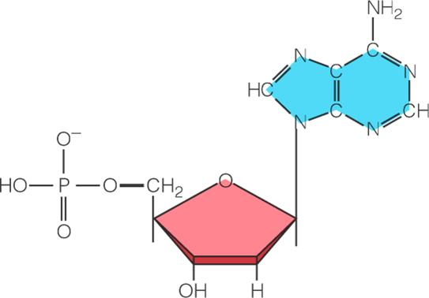

41. There are five nitrogen bases. Which four are found in DNA?

42. Which four are found in RNA?

43. How do ribose and deoxyribose sugars differ?

44. To summarize, what are the three components of a nucleotide?

45. Why are the strands of DNA said to be antiparallel?

46. What two molecules make up the “uprights”?

47. What molecules make up the “rungs”?

48. In a DNA double helix, a region along one DNA strand has this sequence of nitrogenous bases:

5'-T A G G C C T-3'

Write the complementary strand. Indicate the 5' and 3' ends of the new strand.

